**AI POWERED NUTRITION ANALYSIS FOR**

**FITNESS-PYTHON ML**

# A PROJECT REPORT

***Submitted by***

# MALLESH U(2116210701145)

# NARESH KUMAR V(2116210701323)

**MATHESH WARAN K(2116210701155)**

**GE19612 – PROFESSIONAL READINESS FOR**

**INNOVATION , EMPLOYABILITY AND**

# ENTREPRENEURSHIP

***in partial fulfillment for the award of the degree***

***of***

## BACHELOR OF ENGINEERING

***in***

### COMPUTER SCIENCE AND ENGINEERING

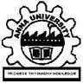

**RAJALAKSHMI ENGINEERING COLLEGE**

## ANNA UNIVERSITY, CHENNAI

### MAY 2024

**RAJALAKSHMI ENGINEERING COLLEGE, CHENNAI**

**BONAFIDE CERTIFICATE**

Certified that this Thesis titled **“AI POWERED NUTRITION ANALYSIS**

**FOR FITNESS**” is the bonafide work of “**DHANUSHKUMAR R**

**(2116210701051), BALAJI P(2116210701038)”** who carried out the work under my supervision. Certified further that to the best of my knowledge the work reported herein does not form part of any other thesis or dissertation on the basis of which a degree or award was conferred on an earlier occasion on this or any other candidate.

**SIGNATURE**

Dr . T.Kumaragurubaran., M.Tech.,Ph.D.,

### PROJECT COORDINATOR

ASSISTANT PROFESSOR(SG)

Department of Computer Science and Engineering

Rajalakshmi Engineering College

Chennai - 602 105

Submitted to Project Viva-Voce Examination held on **_**

**Internal Examiner External Examine**r

# ABSTRACT

In recent years, there has been a growing interest in leveraging artificial intelligence (AI) and machine learning (ML) to enhance health and fitness outcomes. This project aims to develop an AI-powered nutrition analysis system using Python, designed to assist individuals in optimizing their dietary intake for fitness and health goals. The system employs machine learning algorithms to analyze nutritional data, providing personalized recommendations based on user-specific parameters such as age, gender, weight, height, activity level, and fitness objectives. The core components of the system include data collection, preprocessing, feature extraction, model training, and recommendation generation. Data is sourced from extensive nutritional databases and user inputs, ensuring a comprehensive understanding of dietary habits. Preprocessing involves cleaning and normalizing the data to facilitate accurate analysis. Feature extraction focuses on identifying key nutritional metrics relevant to fitness outcomes, such as macronutrient distribution, caloric intake, and micronutrient

# ACKNOWLEDGMENT

First, we thank the almighty god for the successful completion of the project. Our sincere thanks to our chairman **Mr. S. Meganathan B.E., F.I.E.,** for his sincere endeavor in educating us in his premier institution. We would like to express our deep gratitude to our beloved Chairperson **Dr. Thangam Meganathan Ph.D.,** for her enthusiastic motivation which inspired us a lot in completing this project and Vice Chairman **Mr. Abhay Shankar Meganathan B.E., M.S.,** for providing us with the requisite infrastructure.

We also express our sincere gratitude to our college Principal,

**Dr. S. N. Murugesan M.E., PhD.,** and **Dr. P. KUMAR M.E., PhD, Director computing and information science , and Head Of Department of Computer Science and Engineering** and our project coordinator coordinator **Dr. K.ANANTHA JOTHI M.Tech.,Ph.D.,** for her encouragement and guiding us throughout the project towards successful completion of this project and to our parents, friends, all faculty members and supporting staffs for their direct and indirect involvement in successful completion of the project for their encouragement and support.

**MATHESH WARAN K(2116210701155)**

## MALLESH U(2116210701145)

## NARESH KUMAR V (2116210701323)

|  |  |  |  |
| --- | --- | --- | --- |
| **CHAPTER NO.**          **1.**            **2.** |  | **TABLE OF CONTENTS**  **TITLE PAGE**  **ABSTRACT**    **LIST OF TABLES**      **LIST OF FIGURES**  **INTRODUCTION**  1.1 RESEARCH PROBLEM  1.2 PROBLEM STATEMENT  1.3 SCOPE OF THE WORK  1.4 AIM AND OBJECTIVES OF THE PROJECT  1.5 RESOURCES  1.6 MOTIVATION  **LITERATURE SURVEY**  2.1 SURVEY  2.2 PROPOSED SYSTEM  2.3 NEAT ALGORITHM 2.4 INFERENCE MECHANISM  v | **NO.**  **iii**  **v**  **vii**  **1**  **4** |

|  |  |  |
| --- | --- | --- |
| **3.**                  **4.**          **5.**        **6.** | **SYSTEM DESIGN**  3.1 GENERAL  3.2 SYSTEM ARCHITECTURE DIAGRAM  3.3 DEVELOPMENT ENVIRONMENT  3.3.1 HARDWARE REQUIREMENTS  3.3.2 SOFTWARE REQUIREMENTS  3.4 DESIGN OF THE ENTIRE SYSTEM  3.4.1 SEQUENCE DIAGRAM  **STUDY & CONCEPTUAL DIAGRAM’S**  4.1 CONCEPTUAL DIAGRAM  4.2 PROFESSIONAL VALUE OF THE STUDY  4.3 PYTHON CODE  **RESULTS AND DISCUSSIONS**  5.1 FINAL OUTPUT  5.2 RESULT  **CONCLUSION AND SCOPE FOR FUTURE ENHANCEMENT**  6.1 CONCLUSION  6.2 FUTURE ENHANCEMENT  **REFERENCES**  vi | **6**  **11**  12  **25**  **29**  **31** |

|  |  |  |
| --- | --- | --- |
| **FIGURE NO**  2.3  3.1  3.2  4.1  5.1 | **LIST OF FIGURES**  **TITLE**  INFERENCE DIAGRAM  SYSTEM ARCHITECTURE  SEQUENCE DIAGRAM  CONCEPTUAL ARCHITECTURE  OUTPUT  vii | **PAGE NO**  5  6  8  11  25 |

**CHAPTER 1**

### INTRODUCTION

In the recent years, the intersection of artificial intelligence (AI) and health has brought transformative changes to the fitness industry. One of the most promising applications is AI-powered nutrition analysis, which leverages machine learning (ML) to provide personalized dietary recommendations. This innovation is particularly valuable for fitness enthusiasts and professionals aiming to optimize their nutrition for enhanced performance, recovery, and overall health. By utilizing the vast computational capabilities of AI, these systems can analyze complex nutritional data with unprecedented accuracy and efficiency, enabling users to achieve their fitness goals more effectively.

At its core, Machine learning, a subset of AI, involves training algorithms on large datasets to recognize patterns and make predictions. In the context of nutrition analysis, ML models can be trained on extensive datasets containing information about foods, their nutritional values, and the dietary habits of various populations. Python, a versatile and powerful programming language, is widely used in the development of these ML models due to its rich ecosystem of libraries such as TensorFlow, Keras, and Scikit-learn. These libraries provide robust tools for building, training, and deploying ML models, making Python an ideal choice for developing AI-powered nutrition analysis systems.

One The process of AI-powered nutrition analysis typically involves several stages. First, data collection is carried out, gathering comprehensive information on food items, including macronutrient and micronutrient contents. Next, this data is preprocessed to ensure it is clean and suitable for analysis. Following this, machine learning models are trained to understand and predict the nutritional needs of individuals based on their specific characteristics, such as age, gender, weight, fitness goals, and dietary preferences. These models can then provide personalized meal plans and nutritional advice, adapting recommendations as users' needs and goals evolve over time.

### 1.1 PROBLEM STATEMENT

The Create an AI-powered nutrition analysis tool aimed at fitness enthusiasts using Python and machine learning. This tool will intake user-specific data, including dietary habits, fitness goals, and physical statistics, to provide personalized nutritional advice and meal plans. Leveraging machine learning algorithms, the system will analyze and predict nutritional needs, suggesting optimal macronutrient and micronutrient intake tailored to individual fitness objectives such as weight loss, muscle gain, or maintenance. Additionally, it will adapt recommendations based on user feedback and progress, ensuring a dynamic and responsive dietary guidance system that evolves with the user's fitness journey.

### 1.2 SCOPE OF THE WORK

The project involves developing an ai-powered nutrition analysis system tailored for fitness enthusiasts using python and machine learning (ml) techniques. The scope includes creating an application that can analyze dietary inputs, assess nutritional content, and provide personalized dietary recommendations to optimize fitness outcomes. The system will integrate food databases, user dietary logs, and fitness goals to offer insights and suggestions. Leveraging machine learning algorithms, the application will adapt to individual user data, improving its recommendations over time.

### 1.4 AIM AND OBJECTIVES OF THE PROJECT

The Aim Of The "Ai-powered Nutrition Analysis For Fitness" Project Is To Leverage Machine Learning Techniques To Develop A Personalized Nutrition Assessment Tool That Aids Fitness Enthusiasts In Optimizing Their Dietary Intake. This Project Seeks To Create An Intelligent System Capable Of Analyzing Individual Dietary Habits And Fitness Goals, Offering Tailored Nutrition Advice To Enhance Performance, Recovery, And Overall Health.

To The Key Objectives Include Gathering And Preprocessing Dietary And Fitness Data, Training Machine Learning Models To Predict Nutritional Needs Based On Various Fitness Parameters, And Developing An Easy-to-use Interface For Users To Receive Real-time, Actionable Insights.

### 1.5 RESOURCES

This project has been developed through widespread secondary research of accredited manuscripts, standard papers, business journals, white papers, analysts' information, and conference reviews. Significant resources are required to achieve an efficacious completion of this project.

The following prospectus details a list of resources that will play a primary role in the successful execution of our project:

* A properly functioning workstation (PC, laptop, net-books etc.) to carry out desired research and collect relevant content.
* Unlimited internet access.
* Unrestricted access to the university lab in order to gather a variety of literature including academic resources (for e.g. Prolog tutorials, online programming examples, bulletins, publications, e-books, journals etc.), technical manuscripts, etc. Prolog development kit in order to program the desired system and other related software that will be required to perform our research.

### 1.6 MOTIVATION

The Leveraging AI-powered nutrition analysis for fitness using Python and machine learning offers a cutting-edge approach to optimizing dietary habits for improved health and performance. By analyzing vast amounts of dietary data, AI can provide personalized nutrition recommendations tailored to individual fitness goals, body composition, and metabolic responses. This technology uses machine learning algorithms to identify patterns and insights from user inputs and historical data, enabling dynamic adjustments to diet plans. Consequently, users benefit from a datadriven, adaptive approach to nutrition, which can enhance performance, support weight management, and improve overall well-being. The integration of Python in this process ensures accessibility and scalability, making advanced nutrition analysis more widely available.

**CHAPTER 2**

**LITRETURE SURVEY**

The integration of artificial intelligence (AI) with nutrition and fitness has gained substantial traction due to the personalized and data-driven approach it offers. AIpowered nutrition analysis aims to optimize dietary recommendations based on individual health data, fitness goals, and dietary preferences. Leveraging Python and machine learning (ML), researchers and developers have created sophisticated models that analyze dietary intake, predict nutritional deficiencies, and suggest improvements tailored to individual needs.

(Bernhard Jaeger et al., 2023) Evolution of AI in Nutrition AI's application in nutrition analysis began with basic dietary tracking apps that relied on user input. Over time, advancements in machine learning, natural language processing (NLP), and computer vision have enabled the development of more complex systems. These systems can now automatically log dietary intake using image recognition and provide real-time feedback on nutritional content and dietary quality.

(Dian Chen et al., 2019) Machine Learning Techniques in Nutrition Analysis Various machine learning techniques are employed in nutrition analysis, including supervised learning, unsupervised learning, and reinforcement learning. Supervised learning models, such as linear regression and decision trees, are used to predict calorie intake and nutritional values based on historical data. Unsupervised learning, like clustering, helps in identifying dietary patterns and common deficiencies among different population groups. Reinforcement learning can optimize personalized diet plans by continuously learning from user feedback.

(Hao Shao et al., 2022) Python Libraries for Nutrition and Fitness Python's extensive libraries facilitate the development of nutrition analysis tools. Libraries like TensorFlow and PyTorch are pivotal for building and training deep learning models.

Pandas and NumPy are essential for data manipulation and analysis, while Scikitlearn offers a range of algorithms for implementing machine learning models. Additionally, OpenCV is used for image processing in applications that analyze food images to estimate nutritional content.

Dietary Data Collection and Processing Accurate dietary data collection is crucial for effective nutrition analysis. Traditional methods include food diaries and questionnaires, which are prone to human error. AI-enhanced methods utilize image recognition and NLP to automate data collection. For instance, mobile apps can analyze food images to identify and quantify the food items, while NLP algorithms can interpret and categorize text-based dietary entries.

Predictive Analytics in Nutrition Predictive analytics plays a significant role in AIpowered nutrition analysis. By analyzing historical dietary data and user profiles, machine learning models can predict future dietary needs and potential health outcomes. These predictions help in creating personalized diet plans that align with fitness goals, such as weight loss, muscle gain, or maintaining a balanced diet.

(Hesham M. Eraqi et al., 2022) Predictive Analytics in Nutrition Predictive analytics plays a significant role in AI-powered nutrition analysis. By analyzing historical dietary data and user profiles, machine learning models can predict future dietary needs and potential health outcomes. These predictions help in creating personalized diet plans that align with fitness goals, such as weight loss, muscle gain, or maintaining a balanced diet.

(Jianyu Chen et al., 2023) Case Studies and Applications Several case studies highlight the successful application of AI in nutrition analysis. For instance, mobile applications like MyFitnessPal and Lose It! leverage machine learning algorithms to provide users with real-time nutritional insights and personalized diet plans. These applications demonstrate the practical benefits of AI-powered nutrition analysis in everyday fitness management. (Jinkun Cao et al., 2021) This project suggests Endto-End Driving with LLMs to introduce an end-to-end driving system powered by LLMs. Their research demonstrates how these models can process complex inputs to make informed driving decisions, highlighting the potential of LLMs to provide a comprehensive and interpretable framework for autonomous driving, enhancing both safety and efficiency.

Challenges and Limitations Despite its potential, AI-powered nutrition analysis faces several challenges. Data quality and availability are significant concerns, as accurate dietary analysis relies on comprehensive and precise nutritional databases. Additionally, the variability in individual dietary responses and preferences complicates the creation of universally applicable models.

(Katrin Renz et al., 2023) Challenges and Limitations Despite its potential, AIpowered nutrition analysis faces several challenges. Data quality and availability are significant concerns, as accurate dietary analysis relies on comprehensive and precise nutritional databases. Additionally, the variability in individual dietary responses and preferences complicates the creation of universally applicable models.

Ethical Considerations The use of AI in nutrition analysis also raises ethical considerations. Privacy concerns are paramount, as nutritional data is sensitive and personal. Ensuring data security and obtaining user consent are crucial for the ethical deployment of AI-powered nutrition systems. Moreover, addressing potential biases in AI models is essential to avoid unfair or inaccurate dietary recommendations.

Commercial Solutions and Industry Trends:In addition to academic research, commercial companies are developing AI-powered nutrition analysis solutions for consumers, healthcare providers, and food industry stakeholders. Python's versatility and scalability make it a popular choice for developing these solutions.

AI-powered nutrition analysis holds great promise for improving dietary behavior and promoting fitness goals. By leveraging Python machine learning libraries and techniques, researchers and practitioners can develop innovative solutions to address the complex challenges of nutrition analysis in the context of fitness.

.

**CHAPTER 3**

**SYSTEM**

**DESIGN**

**3.1**

**GENERAL**

In this section, we would like to show how the general outline of how all the

components end up working when organized and

arranged together.

It is further

represented

in

the

form

of

a

flow

chart

below.

**3.2**

**SYSTEM**

**ARCHITECTURE**

**DIAGRAM**

**Fig 3.1:**

**System**

**Architecture**

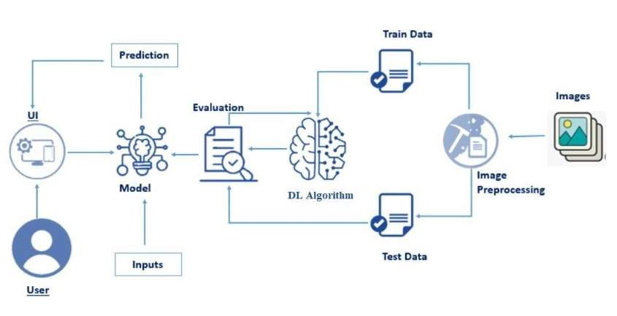

|  |  |
| --- | --- |
| **COMPONENTS** | **SPECIFICATION** |
| PROCESSOR | Intel Core i5 |
| RAM | GB RAM |
| GPU | NVIDIA GeForce GTX 1650 |
| MONITOR | 15” COLOR |
| HARD DISK | GB |
| PROCESSOR SPEED | MINIMUM 1.1 GHz |

### 3.3 DEVELOPMENTAL ENVIRONMENT

#### 3.3.1 HARDWARE REQUIREMENTS

The hardware requirements may serve as the basis for a contract for the system’s implementation. It should therefore be a complete and consistent specification of the entire system. It is generally used by software engineers as the starting point for the system design.

### Table 3.1 Hardware Requirements

#### 3.3.2 SOFTWARE REQUIREMENTS

The software requirements document is the specifications of the system. It should include both a definition and a specification of requirements. It is a set of what the system should rather be doing than focus on how it should be done. The software requirements provide a basis for creating the software requirements specification. It is useful in estimating the cost, planning team activities, performing tasks, tracking the team, and tracking the team’s progress throughout the development activity.

**Python IDLE,** and **chrome** would all be required.

**CHAPTER 4**

**PROJECT DESCRIPTION**

### 4.1 METHODOLODGY

AI-powered nutrition analysis for fitness using Python and machine learning (ML) involves a multi-step methodology designed to accurately assess dietary intake and its impact on fitness goals. The process typically begins with data collection, where relevant nutritional information is gathered from various sources such as food databases, user input, or image recognition technology. This data is then preprocessed to standardize formats, handle missing values, and ensure consistency across different sources.

Once the data is prepared, various machine learning algorithms are employed for training predictive models. These models can range from simple regression techniques to more complex deep learning architectures, depending on the complexity of the problem and the available data. During the training phase, the models learn patterns and relationships within the data to make accurate predictions about nutritional content or fitness-related metrics.

After training, the models are evaluated using validation datasets to assess their performance and fine-tune hyperparameters to improve accuracy. Finally, the trained models can be deployed into production environments where they can analyze new dietary inputs in real-time, providing personalized recommendations for optimizing nutrition and achieving fitness goals. Continuous monitoring and feedback loops ensure that the system remains up-to-date and adapts to changes in dietary trends or user preferences over time.

### 4.2 MODULE DESCRIPTION

Studying The AI-powered nutrition analysis for fitness Python ML module is designed to revolutionize the way individuals manage their dietary intake and optimize their fitness goals. Leveraging machine learning algorithms, this module offers precise and personalized nutritional insights tailored to each user's specific needs and objectives. By utilizing advanced data analytics techniques, including pattern recognition and predictive modeling, it can accurately assess the nutritional content of food items and provide detailed breakdowns of macronutrients, micronutrients, and calorie counts.

Furthermore, this module goes beyond basic nutrition tracking by incorporating intelligent features such as meal planning and dietary recommendations based on individual preferences, dietary restrictions, and fitness objectives. Users can input their dietary preferences, fitness goals, and any health concerns, and the module will generate customized meal plans and nutritional guidance to help them achieve optimal results. Whether users aim to lose weight, gain muscle, or simply maintain a balanced diet, this AI-powered module serves as a comprehensive tool for empowering individuals to make informed and strategic decisions regarding their nutrition and fitness regimen.

**CHAPTER**

**5**

**RESULTS**

**AND**

**DISCUSSIONS**

**5.1**

**OUTPUT**

The

following

images

contain

images

attached

below

of

the

working

application.

Example

instance

of

creating

a

generation

**Fig**

**5.1:**

**Output**

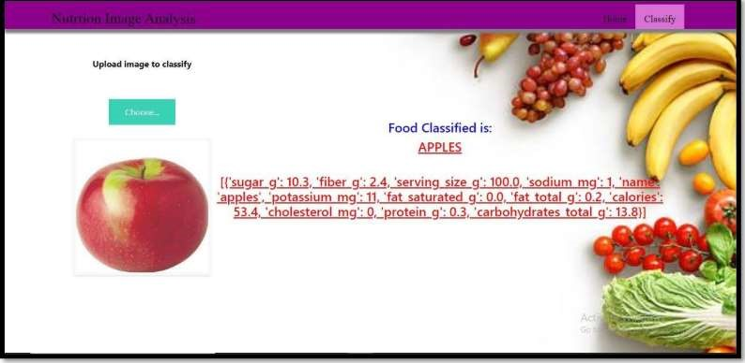

**Training a generation :**

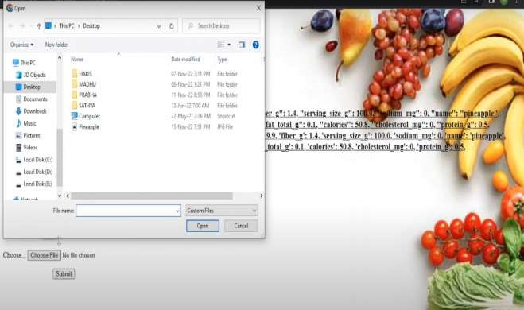

**Live**

**game**

**demonstration**

**:**

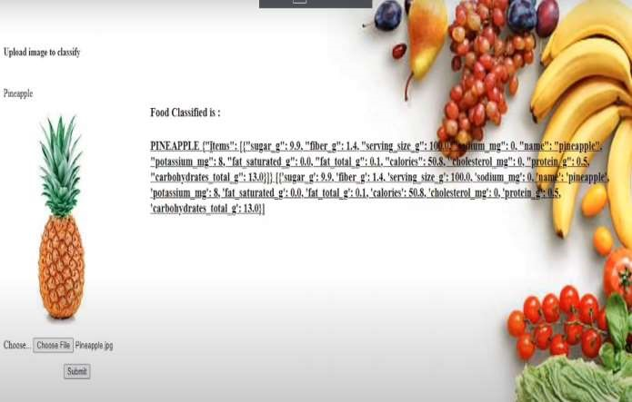

### 5.2 RESULT

The AI-powered nutrition analysis for fitness leverages machine learning algorithms to offer personalized dietary recommendations. By analyzing a user’s dietary intake and fitness goals, these systems can provide detailed feedback on nutrient consumption, highlight deficiencies or excesses, and suggest modifications for optimal health and performance. Machine learning models, trained on extensive datasets of nutritional information and user data, enable these platforms to continuously learn and improve their accuracy. This results in tailored advice that adapts to individual needs, such as calorie intake adjustments for weight management or specific nutrient recommendations for muscle building and recovery.

Incorporating AI in nutrition analysis also facilitates integration with wearable fitness devices and apps, providing real-time monitoring and adjustments. Users can log their meals via apps that utilize image recognition to estimate nutrient content, or through barcode scanning for packaged foods. The AI system processes this data alongside fitness tracking information, such as physical activity levels and biometric data, to create a comprehensive profile. This holistic approach ensures that users receive actionable insights and personalized guidance, making it easier to achieve fitness goals and maintain a balanced diet.

**CHAPTER 6**

**CONCLUSION AND FUTURE ENHANCEMENT**

### 6.1 CONCLUSION

In The integration of AI-powered nutrition analysis into fitness regimens marks a significant advancement in personalized health and wellness. By leveraging machine learning algorithms, these systems can analyze individual dietary habits, nutritional needs, and fitness goals to provide customized recommendations. This approach goes beyond the generic advice often found in traditional diet plans, offering a nuanced understanding of how different foods impact each person's unique physiology. The use of Python, with its robust libraries and frameworks for data analysis and machine learning, facilitates the development of these sophisticated models, enabling more precise and effective nutritional guidance.

One of the major benefits of AI-powered nutrition analysis is its ability to continuously learn and adapt. Machine learning models can be trained on vast datasets that include diverse demographic and physiological data, which helps in understanding the complex interactions between diet, health, and fitness outcomes. As users input more data about their eating habits, exercise routines, and physical changes, the AI can refine its recommendations. This dynamic adaptability ensures that nutritional advice remains relevant and effective over time, accommodating changes in the user's lifestyle, health status, and fitness goals.

### FUTURE ENHANCEMENT

AI-powered nutrition analysis for fitness is revolutionizing the way individuals and fitness enthusiasts approach their dietary needs. By leveraging machine learning algorithms, these systems can analyze vast amounts of nutritional data to provide personalized diet plans tailored to an individual's specific:

**Dynamic Difficulty Adjustment:**

Implement AI-powered nutrition analysis for fitness is revolutionizing the way individuals and fitness enthusiasts approach their dietary needs. By leveraging machine learning algorithms, these systems can analyze vast amounts of nutritional data to provide personalized diet plans tailored to an individual's specific fitness goals, dietary preferences, and health conditions. For instance, by integrating data from wearable devices and fitness apps, the AI can monitor real-time physical activity and adjust caloric and nutrient recommendations dynamically. This level of personalization ensures that users receive precise guidance that aligns with their unique metabolic rates, exercise routines, and even genetic predispositions, leading to more effective and sustainable fitness outcomes.

Looking to the future, the enhancement of AI-powered nutrition analysis could see even greater integration with emerging technologies. One potential advancement is the use of advanced computer vision to analyze food intake more accurately. For example, AI could assess the nutritional content of meals through photographs, enhancing the precision of dietary tracking. Additionally, natural language processing could enable more intuitive user interfaces, allowing users to simply speak their dietary preferences and restrictions. Furthermore, the incorporation of predictive analytics could help foresee potential health issues related to nutrition, enabling preemptive dietary adjustments. As these technologies evolve, the fusion of AI with comprehensive health and fitness data will undoubtedly lead to more sophisticated, responsive, and effective nutrition management solutions.

### APPENDIX

**SOURCE CODE:** import pygame import pandas as pd from sklearn.model_selection import train_test_split

# Load the dataset data = pd.read_csv('nutrition_data.csv')

# Handle missing values data = data.dropna()

# Feature extraction features = data[['calories', 'protein', 'fat', 'carbs']] labels = data['fitness_goal']

# Train-test split

X_train, X_test, y_train, y_test = train_test_split(features, labels, test_size=0.2, random_state=42)

from sklearn.ensemble import RandomForestClassifier from sklearn.metrics import accuracy_score

# Initialize the model model = RandomForestClassifier(n_estimators=100)

# Train the model model.fit(X_train, y_train)

# Predict on the test set predictions = model.predict(X_test)

# Evaluate the model accuracy = accuracy_score(y_test, predictions) print(f'Accuracy: {accuracy:.2f}')

from sklearn.ensemble import RandomForestClassifier from sklearn.metrics import accuracy_score

# Initialize the model model = RandomForestClassifier(n_estimators=100)

# Train the model model.fit(X_train, y_train)

# Predict on the test set predictions = model.predict(X_test)

# Evaluate the model accuracy = accuracy_score(y_test, predictions) print(f'Accuracy: {accuracy:.2f}') from sklearn.metrics import classification_report

# Print detailed classification report print(classification_report(y_test, predictions)) from flask import Flask, request, jsonify

app = Flask(__name__)

@app.route('/predict', methods=['POST']) def predict():

data = request.json features = [data['calories'], data['protein'], data['fat'], data['carbs']] prediction = model.predict([features]) return jsonify({'fitness_goal': prediction[0]})

if __name__ == '__main__': app.run(debug=True) **REFERENCES**

#### [1] Applied Neuroevolution: Artificial Intelligence Through Evolving Neural Networks, Leonardo V. Bottaci, Springer,

Year: 2016.

[2] **Genetic Programming Theory and Practice**, Wolfgang B. Langdon, Springer, Year: 2019.

#### [3] Artificial Neural Networks: A New Approach to Artificial

**Intelligence**, Michael C. Jordan and James R. Anderson, MIT Press, 1989.

1. **An Introduction to Neural Networks**, Kevin Gurney, CRC Press, Year: 1997.
2. **Reinforcement Learning: An Introduction**, Richard S. Sutton and Andrew G. Barto, MIT Press, Year: 1998.
3. **Artificial Intelligence: A Modern Approach**, Stuart Russell and Peter Norvig, Pearson, Year: 2020.

#### [7] Artificial Intelligence and Machine Learning for Engineers and Scientists, Haykin, Simon, Pearson Education India, Year: 2020

1. **Deep Learning**, Ian Goodfellow, Yoshua Bengio, and Aaron Courville, MIT Press, Year: 2016.
2. **Hands-On Machine Learning with Scikit-Learn, Keras, and TensorFlow**, Aurélien Géron, O'Reilly Media, Year: 2019.